Page Grids:

Homepage:
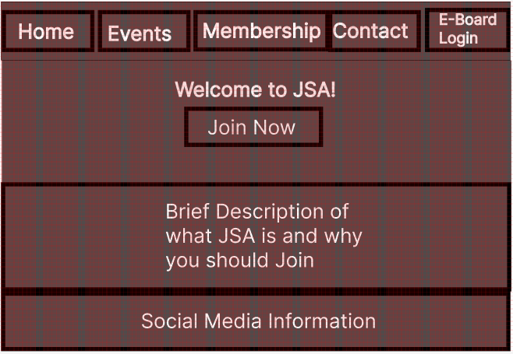
The homepage is going to consist of general information including a brief description of JSA and why you should join JSA. There will be a call-to-action button where the user will click the “Join Now” button and be redirected to the membership page in order to sign up using their personal information including their name, email address and password.

Events Page:
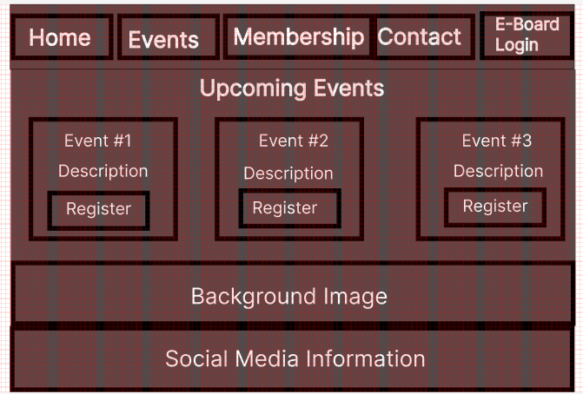
The events page will consist of three most recent upcoming events cards where each event will have a header, a brief description and a button to register. Upon registering, the user will be brought to a confirmation page stating that they are “successfully registered”. There will also be a background image that consists of a sakura blossom as well as social media information in the footer. The header of the page will consist of the navigational bar to bring the user to the different pages that are available.

Membership Page:
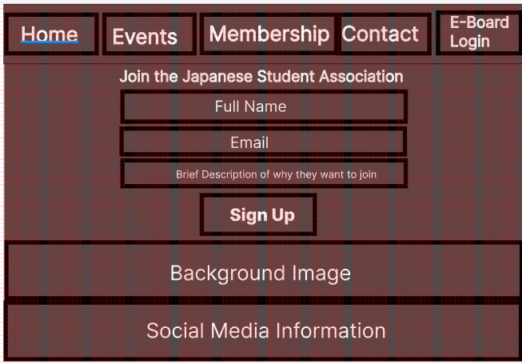
The membership page will consist of a simple form that allows the user to become a member. The form will consist of three different fields: full name, email, and a brief description of why they would like to join the club. The user can then click the sign-up button which will send an email confirmation to the user. The header will consist of the navigational bar to bring the user to the other pages. The footer will contain social media information. The page will also include the Sakura blossom photo in the background.

Contact Page:
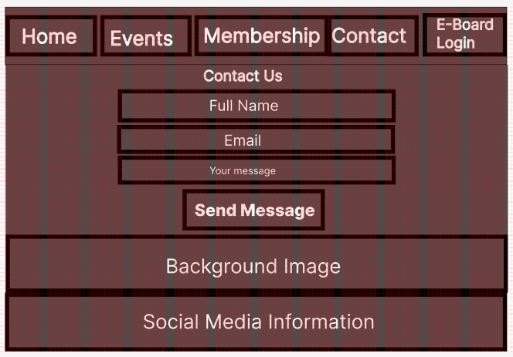
The contact page will be very similar to the membership page. It will consist of three fields: name, email, and a message. Upon clicking the send message button the user will be redirected to a “message sent successfully” screen with a button that allows the user to return to the homepage. The message will be sent to the president of the JSA club.

E-Board Login Page:
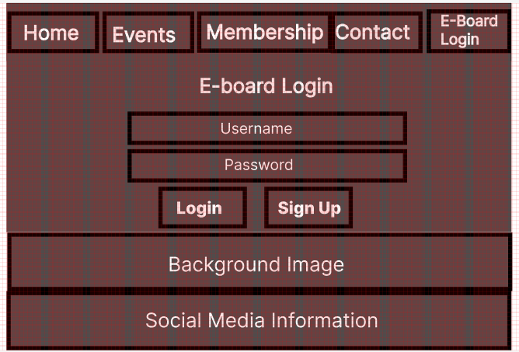
The E-board login page will allow an admin user to be able to login to get to the E-board page. The page will consist of two fields: username and password. Beneath these fields will be a login and signup button. If the user does not have an account, they will be able to sign up for one. Additionally, the page will include the Sakura blossom background image. The header will contain the navigational bar, and the footer will contain the social media information.

E-Board Page:
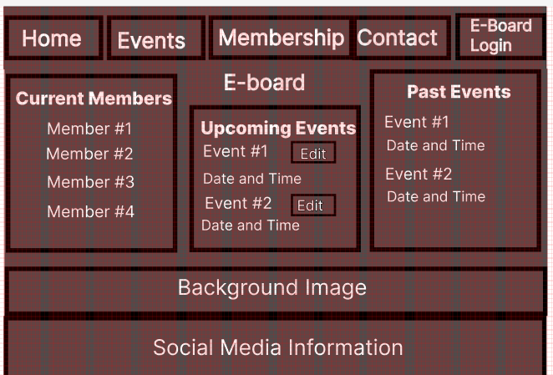
Once the admin is logged in, the E-board page will consist of a list of the current members. There will also be a list of upcoming events with the name of the event and the date and time of it. There will be an edit button next to it, that will allow the admin to be able to edit the event. The page will also consist of a list of past events.

Page Design:
Color Scheme – The color scheme of the website will revolve around the primary colors of red and white which mimic the color scheme associated with JSA. The secondary colors will be a dark grey and black which allows for some contrast to make the content stand out. Red (#E60012) will be utilized for buttons, links and active states in navigation. The secondary color of dark grey (#1a1a1a) will be used for the footer and the background of some sections. White (#fff) will be used for text and background contrast. The background color will consist of a Sakura blossom image with a scrolling effect.
Font- For a more professional aesthetic we will add serif and sans-serif fonts that complement each other. These fonts will also reflect on the cultural aspects of the website relating to the Japanese theme. The primary font will be ‘Noto Sans KP’ which is a Japanese inspired sans-serif font. The secondary font will be ‘Arial’ which is a more popular sans-serif font that will be utilized for the body text for easy readability. The headings will be larger in size in order to create a visual hierarchy while the body text will remain consistent in size and maintain appropriate line spacing.
Multimedia- We want to minimize the overall clutter of images, but we would like to utilize high quality images and videos to reflect the cultural and aesthetic aspects of the website. We will use background images in certain sections, such as the hero section on the home page. We also plan on including images on the cards on the event page. These images will be related to that specific event. The image sizes will be optimized so that loading times are fast without compromising the image quality. Scrollbars will also be utilized to contain larger images and/or videos without overwhelming the page. If videos are needed, we will ensure to utilize video containers with scrollbars so that they do not dominate the layout.
Spacing- To ensure that there is plenty of space, padding and margin will be utilized throughout each section to improve readability and make the content easier for the user to understand. The sections will be placed roughly 50px apart and the elements within each section will have roughly 20px of spacing. Text in headings will be center-aligned to ensure that the page is balanced, and the text within body sections will be left-aligned.

